Every student at Waikato deserves to learn, belong, and succeed — and to do so in ways that reflect who they are and where they come from. This commitment is expressed through Waikato He Wai Māu — The Waikato Way, our Academic Excellence and Student Success Plan, where education is intentionally designed to be coherent, inclusive, and connected across the student journey.
Our 2023–2025 Disability Action Plan has informed and shaped the work that continues today. We are focusing on being clear and direct about what we have achieved, what is underway, and what students and whānau can expect from us. Accessibility and inclusion are part of how we design learning, support students, and invest as a university — not a separate compliance exercise.

Accessibility at a glance
~1,000  Students registered (2025)  Up from 308 in 2021 | 86.6%  Completion rate  Exceeds 83% target | –1.6 pp  Equity gap  Smallest gap on record | 79.5%  Retention rate  At parity with peers

Our journey — a commitment to continuous improvement
2022  Developing the Disability Action Plan in partnership with disabled students and staff. | 2023  Policy foundations strengthened; Students with Disabilities and Impairment Policy completed; peer support pilot programmes launched. | 2024  Accessibility Services expanded; accommodation improvements on both campuses. | 2025  Accessibility embedded in Waikato He Wai Māu; completion rate exceeds target at 86.6%; equity gap at record low of –1.6pp. Reasonable Adjustment Plans digitised and systematised. | Now  Campus mapping underway with BarrierFree; assistive technology catalogue live; communications strategy delivering results; improving continuously.

How we know this is working
Outcome indicators |  | System and engagement indicators
Completion rate  86.6%  Exceeds 2025 target of 83.0%  Up from 78.8% In 2022 . | Equity gap  –1.6 pp  Students with/without disability Narrowed from –5.6 pp in 2022 | Reasonable adjustment plans  Scaled  Digitised, integrated workflows Shared with convenors each semester | Digital reach  43,850  Campaign impressions (peak) Growing social engagement
Retention  79.5%  First-year retention (2024 cohort) At parity with peers | Service reach  ~1,000  Students registered (2025)  Up from 308 in 2021 | Campus mapping  Underway  Wsp contracted November 2025  86 Accessible toilets mapped (Hamilton) | Assistive technology  Centralised  Catalogue live in Alma system  C-pens, magnifiers, microphones available
We are committed to being transparent about progress and continuing to improve the student experience. Data shows strong progress against our Disability Action Plan  targets, with improved completion rates, sustained retention, and a significant narrowing of equity gaps. |  | We continue to use student feedback, service data, and performance measures to guide improvement and ensure that accessibility support remains consistent, effective, and responsive to student needs.

This work is led by the Deputy Vice-Chancellor Academic and delivered through the University's student support, academic, and campus operations teams as part of our core institutional investment. We report on progress through our governance structures, including the Vice-Chancellor's Executive Committee and University Council.
Accessibility Services: waikato.ac.nz/ students/accessibility-services



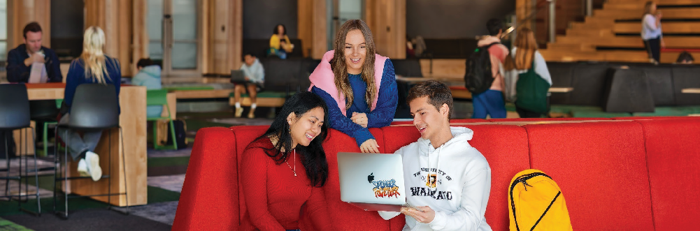
Accessibility and Inclusion
Aligned to Waikato He Wai Māu — The Waikato Way
What we have achieved
- Paper completion rates have risen to 86.6%, exceeding our 2025 target of 83.0% — the strongest result in the reporting period.
- The equity gap between students with and without disabilities has reduced to – 1.6 percentage points, the smallest on record.
- First-year retention has reached parity with peers at 79.5%, indicating sustained progression beyond enrolment.
- Demand for Accessibility Services has grown from 308 students (2021) to nearly 1,000 (2025), demonstrating increased reach and trust.
How we work
Embedded — Accessibility is integrated into our investment planning, student systems, and campus operations
— not a standalone programme.
Student-centred — We work alongside students to understand what is working, what is not, and where to focus next.
Continuous improvement — We use outcome data, service usage, and student feedback to keep raising the quality of the experience we provide.
What you can expect
Whether you are a current student, a prospective student, or a family member, here is what you can expect from us:
- A clear pathway to support — Accessibility Services supports nearly 1,000 students annually and our team will work with you to put the right adjustments in place.
- A Reasonable Adjustment Plan — that is consistently applied across all your papers and learning environments.
- Accessible spaces and environments — actively mapped and improved across Hamilton and Tauranga campuses.
- Staff who are equipped to support you — we invest in inclusive teaching capability so you are not navigating accessibility on your own.
- A university that listens — we use student voice, service data, and feedback to keep improving.

Our current priorities
Making Our Campuses Easier to Navigate
A comprehensive accessibility mapping project is underway with professional services firm BarrierFree, contracted April 2026. Data already shows 86 accessible toilets at Hamilton campus and 9 at Tauranga. Accessible bathroom upgrades continue as part of the Campus Masterplan 2017–2037.
Consistent, Personalised Student Support
Reasonable Adjustment Plans have been digitised and systematised — securely shared with paper convenors each semester. CRM integration enables better tracking of student touchpoints and improved consistency. The next phase focuses on further integration and staff training.
Technology to Support Learning
AI-powered note-taking technology is prioritized for investment. A centralised assistive technology catalogue has been developed in the Alma library system, providing a searchable database of hardware including C-pens, electronic magnifiers, and remote microphones. This has streamlined access and improves allocation tracking.
Inclusive Practice and Engagement
Coordinated communications delivered up to 43,850 impressions on targeted campaigns. A comprehensive 2026 communications plan is being finalized. Staff capability in inclusive teaching and Universal Design for Learning continues to be developed.

