APPLICATION COVER SHEET

Project Details
(Do not use acronyms)
Full Protocol Title:

Name of Primary Applicant:

Faculty/School/Department:

Expected start date: Expected completion date:

Animals species: Number to be used over entire project:
(common name)

Impact Level:
(E.g. No impact , Little impact, Moderate impact. See Q 6 Animal Use Statistics Form – Appendix 1):

Type of Application  (Can tick more than one box): | Research Part of research thesis  Teaching  Other (Specify)

Standard Operating Procedures: | No  Yes: SOP Number/ Title:  If yes, have you been trained in this/these SOP(s)?

Other AEC approval: | Has this application been submitted any other AEC for approval  No  Yes (Specify Committee)  Was the application approved No Yes  Details:

Funding support: | Is this research part of a funding grant either received or pending  No  Yes (Specify funding source)  Details:

OFFICE USE ONLY Protocol Number:
This proposal is approved for the period:

From: To:
Signature AEC Chair: Date:

All research involving the use of animals must comply with the Animal Welfare Act (1999) and the University of Waikato Code of Ethical Conduct for the Use of Animals in Teaching and Research.

Please submit this form to the Secretary, Animal Ethics Committee, Research Office, TSR Block, 3.17, University of Waikato or email animal.ethics@waikato.ac.nz

APPLICATION

Section1: Personnel Information

1.1 PRIMARY APPLICANT (Researcher or student undertaking thesis)
Title, first name, last name:

Qualifications:
Institutional mailing address:

Email: | Phone:
Please detail the relevant experience you have (including the number of years) in the procedures/techniques to be used in this project.

1.2 CHIEF SUPERVISOR (when applicable) to be completed by the student’s supervisor
(it is expected that the supervisor will assist the student with the development of this application)
Title, first name, last name

Qualifications:

Mailing address:

Email: | Phone:
What is your Role in this project?
Please detail the relevant experience you have (including the number of years) in the procedures/techniques to be used in this project.

1.3 other personnel CONTACT DETAILS MUST ALWAYS BE PROVIDED
(Indicate which personnel are handling and which are watching)
Title, First Name, Last Name | Qualification | Contact details | Role in Project
Please detail the relevant experience you have (including the number of years) in the procedures/techniques to be used in this project.

Section 2: Project Description

2.1 LAY SUMMARY OF OVERALL PROJECT (one paragraph)

(To be written in terms that people with a non-scientific background will understand)

2.2 AIM OF THE PROJECT

(Brief and written in terms that people with a non-scientific background will understand)

2.3. BACKGROUND

(Include a short review of previous relevant studies in this area and references where appropriate)

2.4 JUSTIFICATION FOR THE PROJECT

- What are the potential benefits of the research – to humans, other animals, or the environment?

- How will the results of this work be disseminated?

Included in thesis
Peer reviewed scientific journals
Conference presentations
Other

2.5 DESCRIPTION OF PROCEDURES

(Detailed description of all procedures including location where the procedures will take place)

What will happen to the live animals? Give a step-by-step description of all procedures to be carried out on each group of animals. The use of your own flowchart, table or “research design” figure is recommended for complex experiments.

Are there any other procedures that do not involve live animals (e.g. tissue sample analysis etc)? Please provide details.

2.6 DATA COLLECTED AND PROPOSED STATISTICAL ANALYSIS

(Give a clear description of the design of the experiment. Describe the statistical approach that will be used and evidence that the approach can yield answers to the proposed research question.)

2.7 ADDRESSING THE THREE Rs
Replacement, Reduction and Refinement (or the “Three Rs”) are the cornerstone for ethical use of animals in

research, testing and teaching.

(Please complete all three sections – one to two sentences per section)

2.7.1 Replacement (what alternatives to animal use have you considered e.g. computer modelling, non sentient animals)

2.7.2 Reduction (what ways do you propose to minimise the use of animals while still keeping the results meaningful)

2.7.3 Refinement (how have the procedures been refined to decrease the negative impacts these procedures have on animals e.g. analgesic use, appropriate housing, the skill of those involved in the use and care of the animals).

2.8 ANIMALS TO BE USED IN TEACHING (I.E. UNDERGRADUATE LABS)

If no, proceed section 3
2.8.1 | Detail preparation of students for animal use
2.8.2 | Detail supervision of students
2.8.3 | Detail overall relevant experience of students
2.8.4 | Copy of laboratory handout is attached

Section 3: Animals Used and Welfare

3.1 ANIMAL SUMMARY  (Please also complete Appendix 1)  Species scientific & Common name  ONE SPECIES PER LINE |  | Strain  (type of  animal) | Species Code (see Q1 of Animal Use Statistics Form Appendix 1) | Total  number required  (over the life of the project) | Grading of manipulation  (see Q6 of Animal Use Statistics Form Appendix 1)

3.2 WILL ANIMALS BE HOUSED OR HELD (SHORT-TERM OR LONG-TERM)?

If no, proceed to 3.3
3.2.1 | Name of Facility where animals to be housed?
3.2.2 | Describe container (dimensions of cages / pens)
3.2.3 | How many animals per container / enclosure?
3.2.4 | What will be the duration of housing?
3.2.5 | Who will be responsible for the care of the animals?

3.3 PRIOR HISTORY OF THE ANIMALS

(If animals are to be used from another project a summary of the type of project, its protocol number, and other information such as the amount of time between projects etc. is to be stated)

3.4 MANAGEMENT OF ADVERSE EVENTS

(Describe any possible adverse events and how you might manage these. For example, proposed methods of prevention or control such as regular inspection, analgesic regimes and specified humane end points)

3.5 FATE OF THE ANIMALS

(What will happen to the animals at the end of the experiment?)

Section 4: Specific Procedures

4.1 INSTITUTIONAL DRUG ADMINISTRATION ORDER

(See Appendix 2)

Is there an operational procedure required for the use of a product (drug /chemical) in the experiments?

If ‘yes’ this will require an Institutional Drug Administration Order.

Name of Product:

4.2. USE OF ANAESTHETIC
If ‘Yes’ complete the table below

4.2.1 | Name of anaesthetic
4.2.2 | Local or general
4.2.3 | Method of restraint
4.2.4 | Will animals have to recover from anaesthetic? How long is the recovery period?
4.2.5 | How will you deal with post-operative pain and/or discomfort?

Section 5: Declaration

5.1 PERMITS AND APPROVALS
(Are they required and if yes, do you have them)

5.1.1 | Has an application been made to another Committee e.g. Ruakura?
5.1.2 | Are any DOC permits required?
5.1.3 | Are any Iwi approvals required?
5.1.4 | Are any other approvals / permits required?

5.2 DECLARATION |  | CHECK
5.2.1 | I have read and understand the conditions outlined in the Code of Ethical Conduct for the Use of Animals for Teaching and Research.
5.2.2 | I have read the Good Practice Guide for the Use of Animals in Research, Testing and Teaching  https://www.naeac.org.nz/assets/publications/Good-Practice-Guide-Jan-2022.pdf
5.2.3 | If this application is approved, I will inform the Committee of any changes in the project or unexpected outcomes affecting animal welfare, and any event (beyond any approved manipulation) impacting adversely on animal welfare.
5.2.4 | I will submit a complete Animal Use Statistics Form by the specified date.
5.2.5 | I will report as required to the Animal Ethics Committee.

Signed by the applicant:

Date:

I accept responsibility for this project’s compliance with the University’s Code of Ethical Conduct for the Use of Animals for Teaching and Research.

Signed by the Chief Supervisor (if applicable):

Date:

I accept responsibility for this project’s compliance with the University’s Code of Ethical Conduct for the Use of Animals for Teaching and Research.

Appendix 1
Animal Use Statistics Form– one species per sheet
Note: Fill in the YELLOW areas now with the number of animals you propose using (this is part of the application form). The BLUE areas are to be filled in after the research has been completed, and a SIGNED hard copy of this form only is to be submitted to the AEC Coordinator by the completion date indicated on page 1 of this application form. P = Planned to Use AU = Actually Used
1. Animal Type:  (see list on next page) |  |  |  | 5. Re-use: |  |  |  | P |  | AU
 |  |  |  | No prior use
 |  |  |  | Previously used
2. Source of Animals: | P | AU
Breeding unit |  |  |  | 6. Grading: |  |  |  | P |  | AU
Commercial |  |  |  | No impact |  | A
Farm |  |  |  | Little impact |  | B
Born during project |  |  |  | Moderate impact |  | C
Captured |  |  |  | High impact |  | D
Imported into New Zealand |  |  |  | Very high impact |  | E
Public sources |  |  |  | (see attached grading form)
3. Status of Animals: | P | AU |  | 7. Alive: |  |  |  | P |  | AU
Normal/conventional |  |  |  | Retained [by your institution]
SPF/germ free |  |  |  | Returned [to owner]
Diseased |  |  |  | Released [to the wild]
Transgenic/chimera |  |  |  | Disposed of [eg to works or rehomed]
Protected species |  |  |  | Total Alive
Unborn/prehatched
Other |  |  |  | 8. Dead: |  |  |  | P |  | AU
 |  |  |  | Killed for dissection, sampling
4. Purpose: | P | AU |  | Died/destroyed in the course of manipulation/use
Teaching |  |  |  | Euthanased after manipulation or use
Species conservation |  |  |  | Died/destroyed for reasons not associated with manipulation/use
Environmental management
Animal husbandry |  |  |  | 9. Total Manipulated: |  |  | P |  | AU
Basic biological research
Medical research
Veterinary research |  |  |  | 10. Total killed that were bred for research, testing and teaching but not used: |  |  | P |  | AU
Production of biological agents
Development of alternatives |  |  |  | Completed by:  Please print clearly
Other |  |  |  | Designation:
 |  |  |  | Signature:
ANIMAL TYPE CODES:
Type of animal used. No distinctions on basis of sex, age, breed, strain or physiological condition.
$\boxed{BOX 1}$ CODE LETTERS CODE LETTERS
Rodents 1 a Mice Birds 1 p Fowls, Chickens
1 b Rats 1 q Pigeons
1 c Guinea Pigs 1 r Other Birds
1 d Hamsters Miscellaneous 1 s Marine Mammals
Rabbits 1 e Rabbits 1 t Possums
Farm Animals 1 f Sheep 1 u Reptiles
1 g Cattle 1 w Amphibia
1 h Goats 1 x Fish
1 j Deer Other 1 y Other Species
1 k Pigs (°name)
Other Domestic 1 m Horses
Mammals 1 n Dogs
1 o Cats

Grading of Manipulation Examples

Grade A – “No impact or virtually no impact”
Examples:
Mental state: Field observations of grazing behaviour on farms, or benign handling of tame and trained animals that are familiar with all personnel and procedures and with the place where the procedures are conducted.
Food/water: Animals kept outdoors eating their usual food in appropriate amounts; grazing trials on treated pastures; offering supplements to naturally available food; provision of complete, balanced rations to meet all nutritional requirements of animals maintained indoors.
Environmental challenge: Exposure to ambient conditions that are within the thermoneutral range; reduced barometric pressures which do not cause increases in red blood cell production.
Disease/injury/functional impairment: Studies of healthy uninjured animals that are kept in physical conditions which do not themselves lead to injuries such as lameness or compression sores; studies to establish normal characteristics of healthy animals.
Behaviour: Studies of wild or undomesticated animals in their natural habitats; field studies of domesticated animals.

Grade B – “Little impact”
Manipulations of minor impact and short duration
Examples:
Mental state: Experiments on completely anaesthetised animals that do not regain consciousness; simple venipuncture or venisection; injection of non-toxic substances; skin tests which cause low- level irritation without ulceration/erosion; feeding trained animals by orogastric tube; movement of free-range domesticated animals to unfamiliar housing; minor restrictions of water and/or feed intake beyond the normal period of satiation.
Food/water: Water priming for kidney function tests; short-term overall food intake restrictions or excesses that are within usual tolerance levels for the species; short-term changes in dietary composition that cause no clinical signs of deficiency or toxicity, but which would cause such symptoms in the longer term.
Environmental challenge: Exposure to levels of cold or heat that are outside the thermoneutral range, or barometric pressures that increase red blood cell production, but which remain within the capacity of the animals to adapt and do not lead to debility in the long term.
Disease/injury/functional impairment: Studies of vaccines using killed pathogens; tuberculosis tests; induction of mild fever without other debilitating effects; induction of subclinical parasitism; healing of minor superficial incisions, cuts or wounds; minor surgical and/or pharmacological modification of homeostatic capacity (for example, creation of non-obstructive gut fistulae; splenectomy; endocrine gland removal with complete and permanent hormone replacement therapy); physical conditions which cause transient lameness of low intensity, mild compression sores or abrasions.
Behaviour: Mild and short-term physical restraint; keeping free-range domesticated animals in a yard; movement of free-range domesticated livestock to unfamiliar housing; operant conditioning with positive reinforcement in barren laboratory environments; benign preference tests in unnatural surroundings.

Grade C – “Moderate impact”
Manipulations of minor impact and long duration or moderate impact and short duration
Examples:
Mental state: Recovery from major surgeries like thoracotomy, orthopaedic procedures, hysterectomy or gall bladder removal with effective use of analgesics; surgical procedures on conscious animals but with the use of local anaesthesia and systemic analgesic; movement of excitable free-range domesticated livestock to unfamiliar housing; short term capture, handling and restraint of wild or semi-domesticated animals that exhibit marked flight responses; moderate restrictions of water and/or
feed intake beyond the normal period of satiation.
Food/water: Simulation of usual overall intake restrictions often experienced by pregnant/lactating ruminants during cold winters or drought; dietary induction of milk fever in cattle; induction of mild deficiency or toxicity signs by feeding diets containing inadequate or excessive amounts of essential nutrients.
Environmental challenge: Short-term exposure to severe extremes of cold or heat which would lead to collapse if prolonged.
Disease/injury/functional impairment: Studies of live vaccines; induction of clinical parasitism; induction of mild reversible infectious diarrhoea; moderate surgical and/or pharmacological modification to homeostatic capacity (for example, limited gut resection; endocrine gland removal with delayed or incomplete hormone replacement therapy); physical conditions that cause minor chronic lameness or other injuries; studies of the effects of infectious or toxic agents that cause rapid death without distress.
Behaviour: Medium-term restrictions of instinctive behaviour; medium-term holding of ruminants in a metabolism crate; long-term restraint leading to the development of reversible stereotypies; changing social group composition.

Grade D – “High impact”
Manipulations of moderate impact and long duration or high impact and short duration
Examples:
Mental state: Recovery from major surgery under anaesthesia without the use of postoperative analgesics; marked social or environmental deprivation; longer term capture, handling, restraint or housing, without the use of tranquilisers, of wild or semi-domesticated animals that exhibit marked flight responses.
Food/water: Dietary induction of advanced pregnancy toxaemia in sheep or ketosis in dairy cattle; dietary induction of advanced signs of nutrient deficiency or excess; severe deleterious effects of dietary toxins; severe restrictions of water and/or feed intake beyond the normal period of satiation.
Environmental challenge: Prolonged exposure to severe cold or heat that would lead to failure of thermoregulation and collapse, but the exposure is terminated just before those outcomes.
Disease/injury/functional impairment: Studies of severe facial eczema; induction of severe diarrhoea or severe infectious pneumonia; protracted or irreversible pharmacological modification of homeostatic capacity (for example, chemical induction of diabetes mellitus without replacement therapy); marked surgical modification of homeostatic capacity (for example, extensive gut resection; cutting of sensory or motor nerves serving large areas of the body from which no self-mutilation injury results; precise lesioning of limited areas of the brain but with intervention before collapse); physical conditions that cause moderate chronic lameness or other injuries; studies of the effects of infectious and toxic agents that cause either a protracted death with minor distress or a rapid death with moderate distress.
Behaviour: Application of marked and repeated noxious stimuli from which escape is impossible; prolonged periods (several hours or more) of close physical restraint; marked alterations to the perceptual or motor functions of animals to test consequent behaviour.

Grade E – “Very high impact”
Manipulations of high impact and long duration
Examples:
Mental state: Conducting major surgeries without the use of anaesthesia on control animals in assessing efficacy of analgesics; testing the efficacy of analgesics in animals with severe induced pain.
Food/water: Experiments that cause animals to die from poisoning by toxins in the diet; protracted and severe restrictions on water and/or feed intake.
Environmental challenge: Purposeful exposure of conscious animals to lethal extremes of cold, heat or barometric pressure which duplicate naturally occurring conditions.
Disease/injury/functional impairment: Studies of methods for killing pest animals; cutting of sensory or motor nerves serving large areas of the body from which self-mutilation injury results; evaluation of vaccines where death is the measure of failure to protect; studies of the effects of infectious or toxic agents which cause either a protracted death with marked distress or a rapid death with severe distress.
Behaviour: Application of marked and repeated extremely noxious stimuli from which escape is impossible; prolonged periods (several hours or more) of close physical restraint.

Appendix 2

Is an Institutional Drug Administration Order (IDAO) Required?

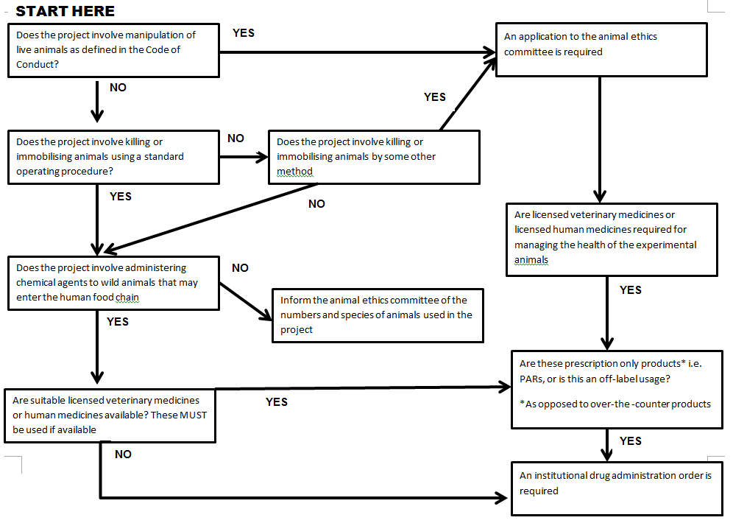

If a decision remains unspecified then no further action is required.

